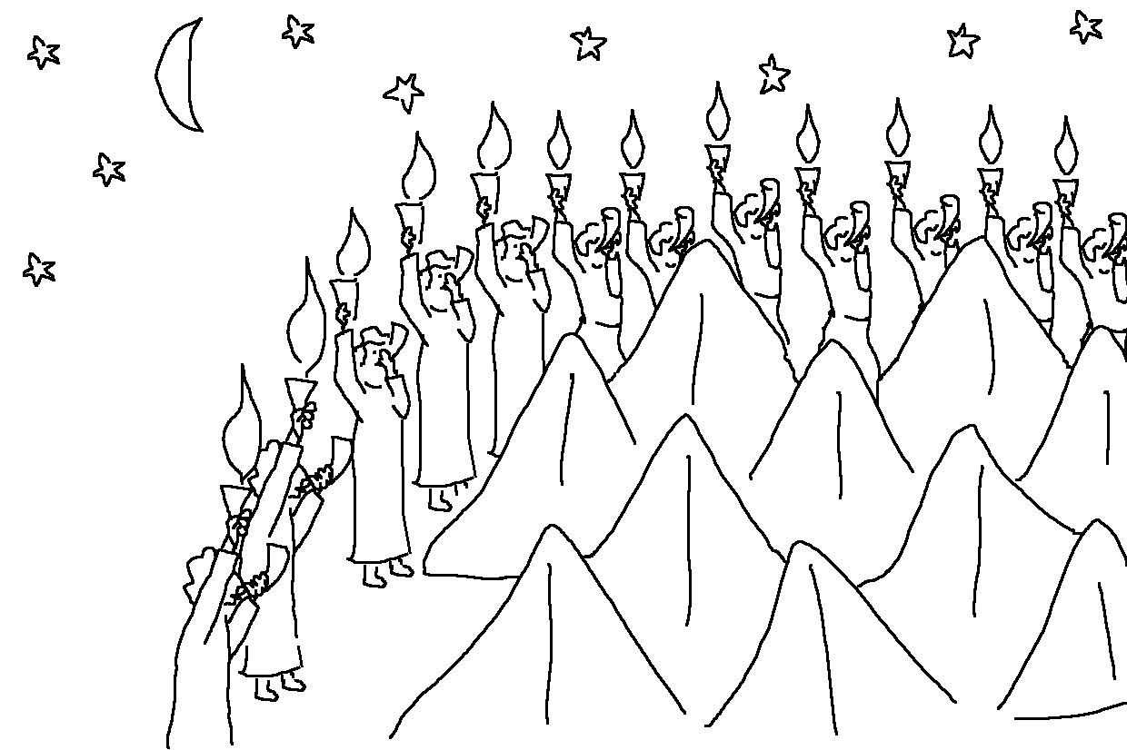
It is not by force, nor by strength, but by My Spirit, says the Lord of Heaven’s Armies. Zechariah 4:6_{NLT}

